# Introduction

This Strategy on a Page (SoaP) guide provides examples, notes and high-level instructions for creating a SoaP artifact from a template. This guide is written with the expectation that the architect is familiar with the Visio and Excel features as covered in the EMAF Quick Reference Cards. Documentation conventions are available in the appendix or [EMWiki](https://wiki.na.xom.com/index.php/EMAF_Documentation_Conventions).

|  |  |
| --- | --- |
| Description | The Strategy on a Page depicts the strategic context in which an organization operates, and the alignment of its goals and objectives, and demands to its vision and mission. |
| Purpose | A purposeful series of activities to align investment plans (P&B) with business strategy |
| Stakeholders | Program Managers, Project Managers, Product Managers, Enterprise Architects, Capability Architects, Solution Architects, System Architect, Release Train Engineers |
| Concerns Addressed | * What Features will be delivered and when? * At which points will we have met individual strategic objectives? |
| Catalogs | * Strategy-Catalog.xlsx * General-Entity-Catalog.xlsx |

## Example(s)

|  |  |
| --- | --- |
| **Example 1:** Strategy on a Page (SoaP) Diagram with the standard layout (Drivers, Vision, Business Objectives, Priorities and Demands) with pre-populated shapes | **Example 2:** Strategy on a Page (SoaP) Diagram with the extended layout (Drivers, Vision, Business Objectives, Priorities, Demands, Benefits, Principles and Mandates) with pre-populated shapes |
|  |  |

## Note(s)

* Use the Document Stencil to access all architecture elements (shapes) required for this diagram.
* External Data Windows are organized by the order elements/shapes appear in the Legend, and then in alphabetical order.

## Instructions

1. Save file in local project folder and set file attributes

* ***File Name***:
  + Option 1: *<Organization / Initiative> Strategy on a Page* - SharePoint friendly (spaces ok)
  + Option 2: *<Organization>-Strategy-on-a-Page*  - URL friendly (use “-“ instead of spaces)
* ***Title***: *<Organization / Initiative> Strategy on a Page*

1. Refresh all linked data to see pre-populated shapes updated with your data: Data -> Refresh All
2. Move existing elements and add/remove elements as required
3. Templates and shapes used within this template are pre-configured with the optimal settings. To change these settings, the Shape Data window needs to be displayed
   * To modify **Shape Data - The Page** (global properties), either
     + Click on diagram background
     + Click on gray buffer area outside diagram
     + Click on the property to modify
     + Enter new value and click **Enter** to have setting change take effect immediately

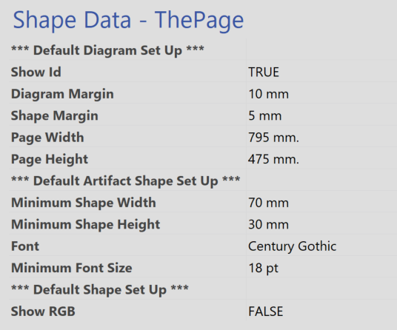

* + - To learn more about modifying **Shape Data - The Page** properties, see
      * Base Element Attributes
      * Business Element Attributes for Benefit properties
  + To modify any shape located on diagram
    - Click on the shape
    - Click on the property to modify
    - Enter new value and click **Enter** to have setting change take effect immediately

WARNING: Only change properties listed under “**** INDICATOR FLAGS ****” (local properties), as changes to any other property will be overwritten during the next data refresh

* + - To learn more about modifying **Shape Data – ‘selected element’** properties, see
      * Business Element Attributes for Benefit properties

1. Use the **Overlay Pallet** (located in the gray buffer outside of diagram) to associate architecture elements that have more than one relationship
   * Click the overlay to duplicate
   * Type **Ctrl+c** and **Ctrl+v**
   * Move the overlay to be adjacent to existing overlays

 

1. Optionally, place the Status Overlay on the top of edge of the shape to show progress on each item



## Tips

1. To minimize your stakeholders from having to scan the diagram for overlays and then associate the overlay to its referenced element, column align related elements as depicted below



1. [Tips to Quickly Build EMAF Visio Diagrams Without Concerns for Page Size or Background Formatting QRC](https://wiki.na.xom.com/index.php/Tips_to_Quickly_Build_EMAF_Visio_Diagrams_Without_Concerns_for_Page_Size_or_Background_Formatting_QRC)

## Appendix – Guide Documentation Conventions

* Object names are in bold font. Examples include: **File** tab, **Enter** button.
* Property names are in bold italic font. Examples include: ***Status***, ***Title***.
* Property values are in italic font. Examples include: *Draft*, *Strategy on a Page*.
* Menu navigation is represented via a **Tab 🡪 Menu 🡪 Sub-menu** convention. For example, **File 🡪 Options 🡪 Display** is equivalent to the following instructions:
  + Click on the **File** tab
  + Click the **Options** menu
  + Click the **Display** sub-menu